**Miss Becky’s Challenges continue:**

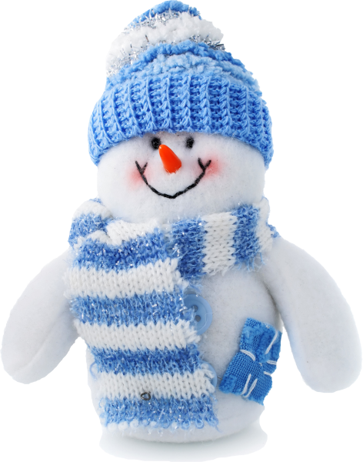

These books can be fiction or non-fiction. When you return your book, tell a staff member something about the book. You will be given a snowman which will be placed around the Tree of Knowledge!

**Prizes will be awarded to three children with the most snowmen!**

**Participate in the Tree of Knowledge**

**Expand your reading with these ideas!**

**Check out any of the following:**

**Book on sports or an athlete**

**Book on folktales**

**A book about or taking place in another country**

**Book on art or an artist**

**Book on music or a musician**

**Start a new series**

**Recommend a book to a staff member**

**A book written in the year you were born**

**A book that is a Newbery or Caldecott Winner**