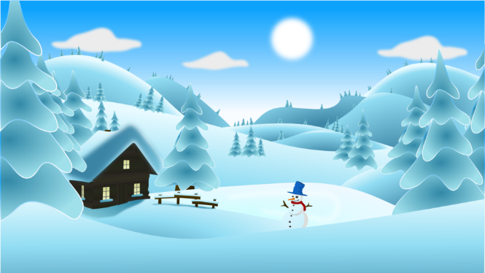

**Waverly Free Library**

**18 Elizabeth Street**

**Waverly, NY 14892**

**(607) 565-9341**

**Winter Reading Sign-Ups**

**Name:** ________________________________________________________________________

**Address:** _______________________________________________________________________

**Phone:** __________________________________ **Age:** _________________________________

**School:** ________________________________________________________________________

**I pledge to read as many minutes / books as possible this winter!**

**My goal is to read _____________ minutes / books**

**Between January 10th – February 28th, 2022**

**Signed ­­­­_______________________**