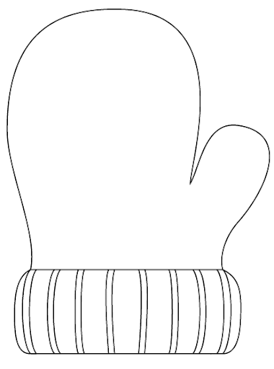

**For every 15 minutes read, color in one mitten**





**Name: ___________________________ Age ______**