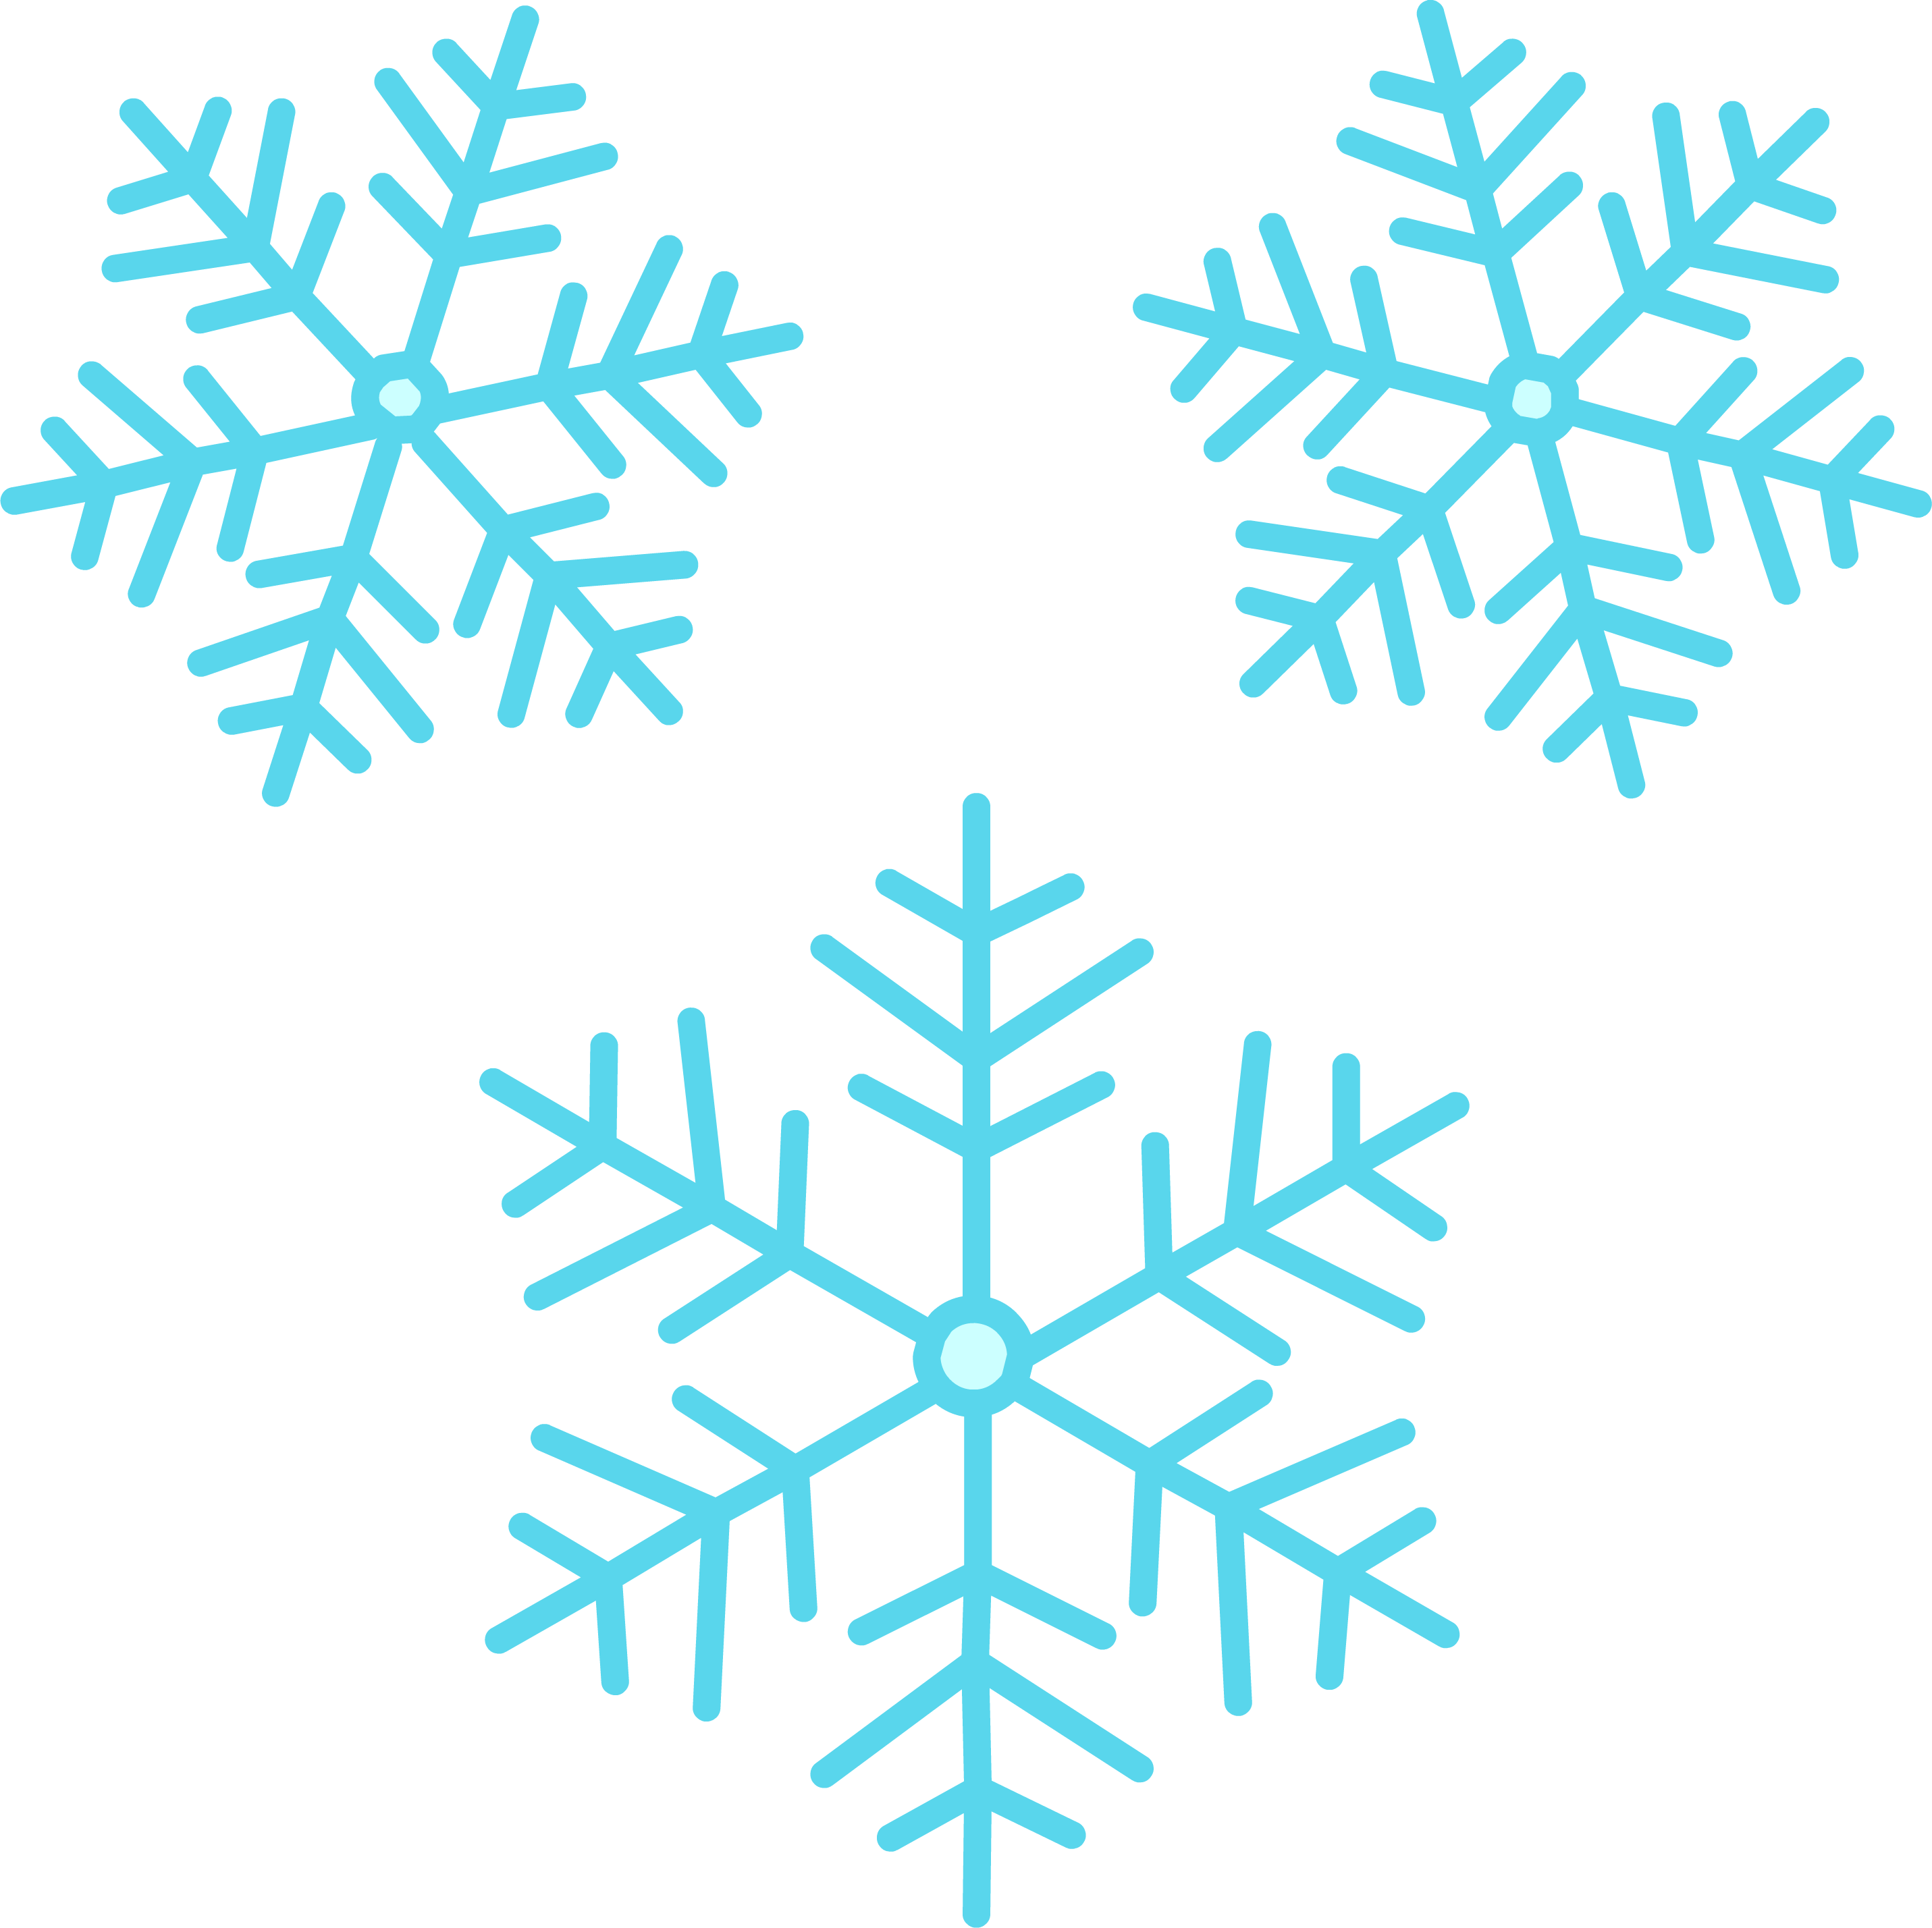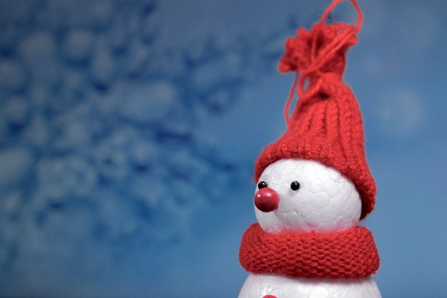

* Take home craft kits will be provided to those children in attendance.

*Tune in for Facebook Live on Tuesday mornings!

**For more information, please call the Waverly Free Library at (607) 565-9341**

**Winter Story Time Themes**

* **Jan. 4th & 6th – Mittens**
* **Jan. 11th & 13th – Snowmen**
* **Jan. 18st & 20th – Hot Chocolate**
* **Jan. 25th & 27th – Chinese New Year**
* **Feb. 1st & 3rd –Groundhog Day**
* **Feb. 8th & 10th – Valentine’s Day**
* **Feb. 15th & 17th – Penguins**
* **Feb. 22nd & 24th – Polar Bears**
* **March 1st & 3rd – Tooth Fairy**
* **March 8th & 10th – Llamas**
* **March 15th & 17th – St. Patrick’s Day**
* **March 22nd – 24th – Spring**
* **March 29th & 31st – Colors**

**Story times will be held every Tuesday at 10:15**

**Toddler times will be held every Thursday at 10:15**